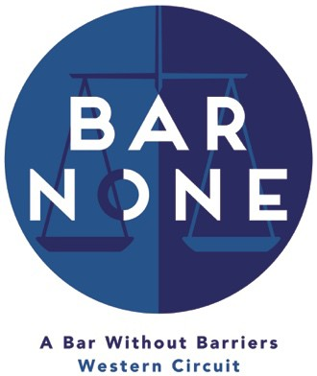

Bar None Mentoring Scheme Mentor Application Form

The Bar None Mentoring Programme is designed to provide support and guidance to those from BAME and/or state school backgrounds with the ultimate aim of increasing diversity on the Western Circuit. To that end this programme will be available to those who express an interest in practice on Circuit and fall within the target group.

We welcome mentors from every background in order to provide this support and guidance. We are passionate about encouraging applications from under-represented groups on the Western Circuit, with our main focus being on state school and BAME backgrounds. However, if you feel comfortable in identifying with one or more of the protected characteristics under the Equality Act 2010 and are able to offer more bespoke mentoring, then please do let us know in the ‘any other comments’ section below. If we can, we will take this into consideration as part of the pairing process.

The plan is to pair mentors and mentees for at least three meetings over the course of a year. We hope that this will encourage practitioners to assist without placing too much of a burden on their time.

Name:

Chambers:

Year of Call:

Contact Email Address:

Town/City currently based in:

Main Practice Area(s):

Did you mainly attend a state school between the ages 11 – 18? Yes/No (delete as appropriate)

Do you consider yourself to fall within the definition of BAME? Yes/No (delete as appropriate)

Have you done any pupil supervisor training, if so, name the provider and the date of the training?

Have you done any equality and diversity training, if so, name the provider and the date of the training?

Any Other Comments

