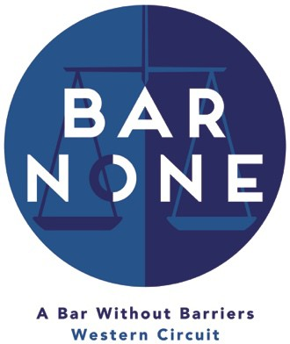

Bar None Mentoring Scheme Mentee Application Form
The Bar None Mentoring Programme is designed to provide support and guidance to those from BAME and/or state school backgrounds with the ultimate aim of increasing diversity on the Western Circuit. To that end this programme will be available to those who express an interest in practice on Circuit and fall within the target group. The plan is to pair mentors and mentees in time for a first meeting in September/October followed by a minimum of three meetings up to July.

Name:

Contact Email Address:

Current stage of legal education:

Town/City currently based in:

Area(s) of law interested in (if known at this stage):

Did you mainly attend a state school between the ages 11 – 18? Yes/No (delete as appropriate)

Do you consider yourself to fall within the definition of BAME? Yes/No (delete as appropriate)

Please provide a short explanation of why you are applying to the Bar None Mentoring Scheme and what you would like to gain from the experience (300 words maximum)

